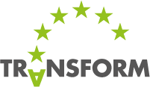

7 STEPS TOWARDS

TRANSFORMATION AGENDA
A Qualitative Decision Support Model
Version 11, 18 March 2015

Jana Kim Koehler
Juergen Ossenbruegge

Jan Riepe
Ulf Skirke
TRANSFORM Project Team

CONTENT

PREAMBLE 3
0. INTRODUCTION 5
HOW TO USE THIS DOCUMENT 7
I. OVERVIEW OF THE 7 STEPS 8
II. DESCRIPTION OF THE 7 STEPS 10
1. SETTING TARGETS 10
2. DETERMINATION AND ANALYSIS OF STATUS QUO 12
3. FIND FOCUS POINTS TO IMPROVE DEVELOPMENT TOWARDS TRANSFORMATION STRATEGY 15
4. ADJUSTMENT OF STRATEGIC CONCEPT TO THE CITY SYSTEM AND INCREASE OF IMPACT 17
5. TRANSFORMATION AGENDA AND DECISION SUPPORT ENVIRONMENT 20
6. PROCEDURES AND CITY DYNAMICS OF MONITORING, EVALUATION AND ADAPTATION 24
7. COMPOSITION OF THE TRANSFORMATION AGENDA 26
III. ANNEX 28
ANNEX 1: SWOT AND PESTLEGS FRAMEWORK 29
ANNEX 2: BASELINE ANALYSIS 31
ANNEX 3: SMART ENERGY CITIES QUESTIONNAIRE 32
ANNEX 4: GUIDING QUESTIONS 33
ANNEX 5: LIST OF KEY PERFORMANCE INDICATORS 34
ANNEX 6: STAKEHOLDER MAPPING 35
ANNEX 7: INTAKE WORKSHOP 36
ANNEX 8: CITY AS COMPLEX ADAPTIVE SYSTEM AND SMART GOVERNANCE 37
ANNEX 9: EXAMPLES OF BUSINESS MODELS 43
ANNEX 10: ROADMAP TO MAKE AN IMPLEMENTATION PLAN 46
ANNEX 11: QUANTITATIVE DECISION SUPPORT ENVIRONMENT 47

PREAMBLE
European Cities are at the beginning of a profound transformation process that shall lead to sustainable and livable conditions on the basis of responsibly designed, resource efficient and low-emission urban structures and functions. Thereby, the cities take part in the challenge of global transition and search for answers related to both the intensive world-wide networks as well as the cultural traditions of European cities.
Various transformation fields (PESTLEGS) have to be considered in order to outline the contents and the frame of the transformation, and in order to specify the necessary elements of shifts which are considered inevitable. These fields shall be contemplated both individually and in combination with each other, and furthermore, have to fit into the city-specific framework and particularities. Therefore, the PESTLEGS are likewise giving a unified example for the transformation management of metropolises as well as a city-specific selection of objectives, instruments and project steering.

Political
The transformation towards the smart city leads to a new and growing field of urban energy politics which coordinates economic, technological, social and environmental aspects. It thus becomes a crucial subject for urban political representatives and decision makers. The success of the transformation process requires extensive mobilisation, leadership capacity, long term vision and planning skills involving a broad spectrum of actors, stakeholders and citizens. Smart cities are embedded in multilevel institutional structures with direct links to regional, national and European policy frameworks.

Economic
The transformation towards the smart energy city leads to smart growth due to the promotion of innovative economic activities, entrepreneurship and the win-win situation of resource and cost efficiency. Smart cities will be places where energy based economic production and service clusters may emerge which are characterized by opprtunities of new business opportunities, start ups and technological leadership leading to “green” agglomeration economies.

Social
Transformation towards the smart energy city leads to an integrative city because the framework strategy is socially balanced (refurbishment, payable rent) and creates new forms of social interaction and inclusive activities on the level of households, neighborhoods and urban quarters. It builds on social business models (e.g. contracting) aiming at higher social fairness in the long term. Centralized urban energy systems such as district heating and cooling as well as open energy systems improve various forms of social and economic participation. The transformation process promotes awareness for smart and sustainable development, public communication and self-commitments from industry, citizens, institutions to behave in a climate friendly, energy-saving manner.

Technical
Transformation towards the smart city leads to continued technological dynamics, research and innovation within the fields of energy production, distribution and consumption (e.g. smart grids, energy storage, renewables etc.). It leads to cost-effective local resource efficiency, energy saving attitudes and new, bankable, varied business models. It contributes to spreading e-mobility and to the transformation of technical infrastructures for an energy efficient and flexible city. It respects regional differentiation in technological solutions caused by different natural conditions and cultural heritage.

Legal
The transformation towards the smart city leads to new organizational forms of contracting, planning and business models and self-organized initiatives challenging existing local and national planning regulations. New institutional arrangements such as “open data” at EU level are of major concern (from districts to EU energy mapping) and the Transform project can play a unique role in delivering recommendation.

Environmental
The transformation towards the smart city is an integral part of sustainable development because it demands growing resource efficiency and builds on renewable resources. It is a comprehensive commitment towards systemic change and management leading to a green city. It includes a conception of time reflecting ecological and socio-economic dynamics which support the choice between short, middle and long term measures with respect to natural conditions and cultural heritage.

Governance
Transformation towards the smart city leads to new forms of cooperative organization of the civil society and network activities of various stakeholders. The transformation process initiates political action, supports change agents, empowers and creates an atmosphere of trust on values and players, capacity to act and responsibility. This type of governance, as a combination of a bottom-up and top-down approach, serves as guarantee for a broad social acceptance of urban change towards the goals of smart city. It is a source of political pressure to keep the transformation process running and helps balance political action and stakeholders’ support.

Spatial
The transformation towards the smart energy city leads to a citizen-centered planning and spatial development based on mixed functions, compact structures and decreasing pollution. It helps to find a sustainable balance between dense inner city and suburban parts of the metropolitan region as well as between commercial, green and blue areas. Spatial development builds on smart infrastructure networks, creates new urban amenities and improves resilience in view of climate change.

INTRODUCTION

The TRANSFORM project aims at helping and accelerating European cities’ shift towards smart energy systems and sustainable development. Faced with increasing volatilities of the existing energy system, and in line with previous documents like the Covenant of Mayors, the Sustainable Energy Action Plans (SEAP) or Cities of Tomorrow, the vision of TRANSFORM includes far reaching socio-technical changes to improve urban well-being, reduce greenhouse gas (GHG) emissions and increase resilience of cities.
At the beginning of the project the TRANSFORM team reflected on its definition of a Smart Energy City with a negligible carbon footprint. This definition also forms the vision of achievements by European Cities at the end of a true TRANSFORM process:
“The Smart Energy City is highly energy and resource efficient, and is increasingly powered by renewable energy sources; it relies on integrated and resilient resource systems, as well as insight-driven and innovative approaches to strategic planning. The application of information, communication and technology are commonly a means to meet these objectives. The Smart Energy City, as a core to the concept of the Smart City, provides its users with a livable, affordable, climate-friendly and engaging environment that supports the needs and interests of its users and is based on a sustainable economy.”
The challenging question now is how to attain this vision? The answer may be given by a Transformation Agenda. It can be anticipated that there will be neither a general solution matching all European cities nor a patent remedy for an individual city. “Moving toward Energy Smart Cities implies a radical change of paradigm and needs new models for strategic sustainable planning which leads to new kinds of interaction between politics, society, science, technology and the economy. [...] It brings together the main issues that are part of the Smart Energy City, including governance, institutional failure, investment agendas and financial strategies” (TRANSFORM Description of Work, Page 27). This shall be achieved by using learnings as well as experiences from the cities’ Smart Urban Labs in permanent iteration.

Hence, a Qualitative Decision Support Model is needed – in the following named as Generic Transformation Agenda (GTA).
A Generic Transformation Agenda is a general concept which aspires to serve as a guideline for cities that want to embark on the path towards decarbonisation, increasing both their use of renewable energies and the level of energy efficiency. This GTA is based on the idea that regime shifts are long-term non-linear processes of change which cannot be strictly ruled but certainly directed through impact on transformation dynamics. To exert that impact, it takes interaction with various stakeholders and multi-actor networks, pro-active use of multi-level dynamics and governance, technological innovation and a fresh take on urban planning as well as the acceptance of uncertainty about future internal and external pressures. In line with recent findings in the transition research, the GTA is proposed as a guideline which translates abstract knowledge of complex systems to a practical management framework. It builds on the experience of TRANSFORM partners and their City Transformation Agendas.

This document offers guidance for the development of tailor-made Transformation Agendas, suiting the unique character of a city and exploiting its specific strengths. Seven steps comprise a range of different elements and tools, based on experience from the TRANSFORM project. It is equally conceivable to use the GTA as a source of inspiration and to apply only a selection of the elements if this satisfies the city’s needs best. Possible pathways towards decarbonisation, increasing use of renewable energies and rising energy efficiency rely on multiple exogenous and endogenous drivers of urban change. This GTA distinguishes two principles, one related to transformation objectives, one to transformation governance.
Transformation Processes include far reaching socio-technical changes, which are related to traditions and cultures, social and political structures and planning, and everyday practices. Thus, a comprehensive elaboration of the relevant context is a necessary precondition. To breakdown the macro-environment this GTA makes use of the PESTLEGS Scheme (see Annex 1: SWOT and PESTLEGS Framework an PREAMBLE) which allows outlining relevant challenges of the Transformation Process. This scheme, which has been elaborated within the TRANSFORM project, allows a multi-perspective evaluation of challenges, barriers and chances from different urban fields that already exist or may come up during the Transformation Process. A successful Transformation Process depends on the proper handling of governance issues and the use of management tools. The GTA suggests approaches that outline a perspective on the transition path, its management and seven distinctive phases of urban Transformation Management. The core of the Transformation Agenda is the establishment of a continuous process, which ensures long-term development towards a Smart Energy City and includes recurring corrections to reduce the deviations between an ideal SEAP and real SEAP (Figure 1). Transformation Management may be conceptualized as a sequence of key activities: the preparation, envisioning and target setting, planning and implementing, monitoring, and evaluation of the Transformation Process. These five activities facilitate a regular adaptation of the Transformation Agenda to incorporate innovation step by step. This cycle is non-linear and interactive. The City of Hamburg for instance carries out a revision of its central concept every two years. This combination of Transform Vision, Management Cycle and ongoing correction of the Transformation Path is a first approach to understand and to direct long-term development on urban level. Further steps will be outlined throughout this document to include the different components of a city and to illustrate the city as a whole as complex adaptive system.
Figure 1 (a): Basic components of Transformation Management and Transformation Path towards long-term goals and vision.

HOW TO USE THIS DOCUMENT
While the SEAP Guidebook “How To Develop a Sustainable Energy Action Plan” provides a coherent stream and wealth of information regarding the development of a local energy and climate strategy, the suggestions combined in this document shall support the acceleration of the development process towards a Smart Energy City. The suggestions for the development of a Transformation Agenda represent a summary and overview of essential steps to formulate a strategic concept, building on existing approaches and partly recombining elements presented in the SEAP Guidebook.
This compilation of suggestions places its emphasis on easy access and reduced complexity to stimulate application in practice. It is complemented by illustrative examples and experiences gained by TRANSFORM cities which have been collected during the TRANSFORM project.
This document is structured in three parts:
- Overview of the 7 Steps as an introduction to the whole process
- Description of the 7 Steps, illustrated by examples and references where available
- Annex with detailed references

OVERVIEW OF THE 7 STEPS

1 | SETTING TARGETS | The 7 steps begin with a strong vision and clear definition of targets by the city. The vision and targets have to be agreed upon by the main political stakeholders. Strong stakeholder involvement is important in order to ensure action. The targets should include short-, medium and long-term components to provide milestones all along the path towards the vision.
 |  | Page 10
2 | DETERMINATION AND ANALYSIS OF STATUS QUO | In order to identify the best measures towards Transformation it is necessary to analyze and evaluate the current state of the city relative to the targets and vision. The TRANSFORM suggests four main tools that assist the determination of the Status Quo: a Baseline Analysis including important facts, a Status Quo Report concerning the city context, a strategic City Concept Assessment along Guiding Questions and an evaluation according to a list of Key Performance Indicators. Key stakeholders should be identified through the process of Stakeholder Mapping and should be involved in projects and decision-making at an early stage.
 |  | Page 12
3 | FIND FOCUS POINTS TO IMPROVE DEVELOPMENT PATH TOWARDS TRANSFORMATION STRATEGY | Prioritizing which themes to act on, and in which order, is essential. The Transformation Agenda should focus on the crucial challenges which enable significant advancements towards the city’s targets. Therefore, as part of the third step, so called Intake Workshops are organized, involving staff members from across the city administration, stakeholders and knowledge partners. These workshops are useful to examine challenges, brainstorm and discuss potential solutions. This process is supported by the use of the SWOT and PESTLEGS analysis tools, and furthermore a calibration of the concept along Guiding Questions.
 |  | Page 15
4 | ADJUSTMENTS OF STRATEGIC CONCEPT TO THE CITY SYSTEM AND INCREASE OF IMPACT | Cities are complex and difficult to manage due to diverse groups of interest, hence, Step 4 draws attention to the city as a complex adaptive system and to encourage the creators of the city concept to search for links and possibilities to intervene sensibly in the system.  A good city concept is closely connected to its targets and vision. The higher the levels of participation and intervention in the city development process, the higher the level of possible impact.
 |  | Page 17
5 | TRANSFORMATION AGENDA AND DECISION SUPPORT ENVIRONMENT | The development of a Transformation Agenda, which includes a specific Action Plan, plays an essential role for reaching the set targets – actions and measures are the means to turn the strategy into reality. An Implementation Plans is a concrete application of tangible measures in a particular district of the city, aligned to the short- and medium-term targets. A great help for the evaluation and decision on the right actions can be the specifically for this purpose developed Decision Support Environment provided by TRANSFORM.
 |  | Page 20
6 | PROCEDURES AND CITY DYNAMICS OF MONITORING, EVALUATION AND ADAPTATION | A long planning horizon in the range of several decades is the basis to succeed in profound transitions. A city needs to be able to adapt to its dynamics, which means an ongoing feedback process with continuous loops of adaptation. The process of monitoring and evaluation requires iteration on a regular basis in order to reach the desired Transformation towards a Smart Energy City. Through this, deviations from the desired path can be recognized at an early stage and the city can react according to the set targets. The process of monitoring and evaluation is therefore inevitable.
 |  | Page 24
7 | COMPOSITION OF THE TRANSFORMATION AGENDA | The assembly of the results originating from the previous 6 steps leads to the conception of the Transformation Agenda in this final step. The strategy of the Transformation Agenda focuses on the long-term perspective while its measures direct to the short- and mid-term development of the city. Furthermore, the integration of accompanying research, experts and consultants can enhance the agenda’s level of quality. With respect to innovation and creative change management, space for niches and experiments should be considered in the strategy. Frontrunners and change agents should be encouraged by the city concept. Diversity is assumed to be more robust than “one best way”.
 |  | Page 26

DESCRIPTION OF THE 7 STEPS

SETTING TARGETS

For 2020, the European Union has committed to the ambitious 20-20-20 targets. This means cutting 20% of the greenhouse gas emissions compared to the 1990 level, increasing energy efficiency by 20% and meeting the energy demand with 20% from renewable sources. “This limited set of EU-level targets is translated into national targets in each EU country, reflecting different situations and circumstances”. For 2030, the EU target is reducing emissions by 40%, for 2050 Europe's greenhouse gas emissions have to be reduced by 80 to 95% compared to 1990 levels. Against this background each city ought to find the right level for its individual reasonable targets, divided into short-, middle- and long-term targets. In order to make a real difference, targets should be ambitious, given the findings of the latest Synthesis Report by the Intergovernmental Panel on Climate Change:
“Continued emission of greenhouse gases will cause further warming and long-lasting changes in all components of the climate system, increasing the likelihood of severe, pervasive and irreversible impacts for people and ecosystems. Limiting climate change would require substantial and sustained reductions in greenhouse gas emissions which, together with adaptation, can limit climate change risks. [...] Many adaptation and mitigation options can help address climate change, but no single option is sufficient by itself. Effective implementation depends on policies and cooperation at all scales, and can be enhanced through integrated responses that link adaptation and mitigation with other societal objectives.”

Furthermore, the Climate Conference 2014 in Lima, as a preparation of the main conference in Paris 2015, gives an important framework concerning the outcomes of TRANSFORM. World leaders are expected to sign an agreement to limit greenhouse gas emissions from 2020 onwards at a Paris Conference in December 2015. European city activities on climate and energy action can support and underline the spirit of this international agreement, supporting the ‘Energy Union Package’ by the European Commission including ‘The Paris Protocol – A blueprint for tackling global climate change beyond 2020’.
A ‘simple’ model of Transformation describes and illustrates the transition process to achieve a low-carbon society and to avoid rebound effects and climate crisis in a 1st Approach (see Figure below).

Figure 2: The transformation’s temporal dynamics and action levels. Central to the transformation is the decarbonisation of the energy system (Source: WBGU).

To work out the long-term Vision (e.g. 2030 to 2050) of the City Concept the method of Backcasting (the feasibility assessment of desired future) can be useful:

- Setting a desired future (e.g. sustainability)
- Analysing the present situation in relation to the desired future
- Envisage future elements
- Step-by-Step strategy towards the desired future (elements)

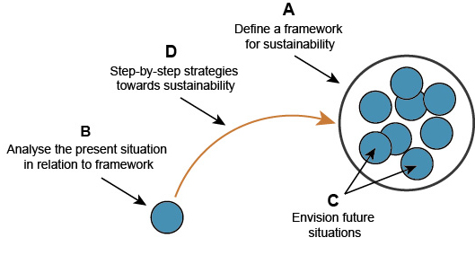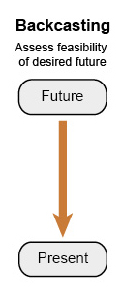
Figure 3: The Method of Backcasting
In order to reach the long-term CO₂ reduction Vision, the approach has to be dynamic. Therefore, it needs to be taken into consideration that the political boundary situations might change and the technical development is unforeseeable. We have to consider a nonlinear character of the Transformation Process which will be illustrated in Step 2.
As indicated above, the frame for setting the target is given by the European Union. Cities develop their own focus on specific fields of action within their targets. The use of the City Concept Assessment along Guiding Questions, as presented in Step 2, can help to obtain an overview of the possible fields of action. A categorization of targets can be delivered by Key Performance Indicators which can also be found in Step 2. The targets and fields of action are to be transferred to the City Transformation Agenda.

DETERMINATION AND ANALYSIS OF STATUS QUO

The analysis and assessment of the current city’s position with respect to the defined targets is a basic step and starting point. If a concept that describes the planned path towards the targets is already available a possible deviation from this path should also be recognised. But the present starting point shows a history in the past: the former starting point passed through a process of planning, acting, monitoring, evaluation – until the present and future starting points. The assessment of targets and starting points exposes a nonlinear dynamic: acting and management of the Transformation Process are continuously adaptive. Therefore, a 2nd Approach of modeling and illustrating Transformation can be named “Adaptive Management Cycle” (see Figure 4).
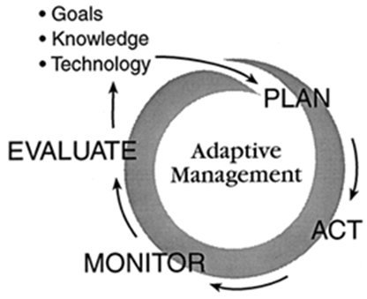
Figure 4: The Adaptive Management Cycle
The acquisition of suitable data and monitoring processes support this task as discussed later on in Step 7.
As illustrated by Figure 5, the combination of four tools – Baseline Analysis, Status Quo Report (SQR), City Concept Assessment, and a List of Key Performance Indicators (KPIs) – can help to achieve the desired results. Stakeholder Mapping describes the human side of interrelations within the city.
Results & Overview
Figure 5: Determination of the Status Quo via different elements for self-analysis and self-assessment of the city.

BASELINE ANALYSIS
In order to start the transformation towards a Smart Energy City, each city needs to define a reference point (baseline). This analysis should provide a static snapshot in time – ready to be transformed. A baseline analysis can be performed best when a lot of up-to-date data is made available within the city. It consists of facts delivered by figures. More context with respect to the Baseline Analysis is provided in Annex 2: Baseline Analysis. The TRANSFORM project has elaborated a Questionnaire (Annex 3: Smart Energy Cities Questionnaire) which can serve to compile a good basis of relevant information and can be used to monitor a city’s progress towards becoming a smart energy city.

STATUS QUO REPORT
The Status Quo Report (SQR) is a description based on the available city data on economy, socio-demography, standards of living, traffic and transportation, climate, geography, resource consumption, as well as urban development and environment. Overall it is a synopsis of the current policies and activities in the city and provides an overview of possible field of action in the future. It can be a qualitative complement to the Baseline Analysis. The result can be used as a first approach towards analysing the strengths, weaknesses, opportunities and threats (SWOT).

CITY CONCEPT ASSESSMENT
The first step of a self-assessment within the Status Quo definition links existing Energy/Climate Concepts to basic questions which allow a comparative evaluation. Within TRANSFORM, twelve Guiding Questions concerning the city concept have been outlined (see also Annex 4: Guiding Questions) and answered by the participating cities. This assessment can be seen as a first approach towards identifying city concept characteristics, allowing a better development of the City Transformation Agendas.

Question | Exemplary answer from Cities
- Definition of objective(s): How is the (main) objective/aim of the city plan defined? | Copenhagen: The overall target of the Copenhagen Climate Plan 2025 (CPH 2025) is to turn Copenhagen into the world’s first carbon neutral capital by 2025.
- What is the underlying “philosophy” of the plan? | Hamburg: The plan follows a holistic and comprehensive approach.
- Does the plan provide a specific timeline? | Vienna: Main objectives are defined by long-term targets (2050), middle-term Targets by 2030 and short-term targets by 2020.  Copenhagen: The overarching goal for CPH 2025 is that by the year of 2025 Copenhagen must be carbon neutral. The process of implementing CPH 2025 is split into three periods: 2013-2016, 2017-2020 and 2021-2025.
- Is the achievement of objectives monitored? | Copenhagen: CPH 2025 is being monitored on a yearly basis. This includes a status on all initiatives qualitatively speaking to assess whether progress takes place.  Hamburg: The Master Plan, as a long-term development plan for climate protection and the Climate change impact adaptation in Hamburg, has to be regularly adapted to the current developments and revised. To this end, the Senate updates it every two years.
- Is technical and social innovation taken into consideration as an accelerator/catalyst for the city concept? | Amsterdam: Yes, the program appoints the need for innovation and behavioral change (it’s calculated that otherwise 25 % of the climate goals will not be achieved). Both technical and social innovations take mostly place in the organization of Amsterdam Smart City, by working in three living labs. Financial and policy innovation takes place within the municipality. The Amsterdam climate and energy fund is an example.  Vienna: innovation is one of the 3 main objectives and drivers of the SCW Framework Strategy. There is a common understanding that without social and technical innovations all the other goals in terms of energy efficiency and CO2 reduction won’t be achieved!
- Does the plan reflect the spatial differentiation in terms of city scales (e.g. building-, quarter-, district- or area-scale)? | Hamburg: The City Plan is focused on the entire city space. In total the spatial dimension has to be improved.  Vienna: Only slight spatial differentiation.  Genoa: High level of differentiation with integrative view on different city scales.
- Does the city plan concern other themes of politics/governance? | Vienna: The SCW Framework Strategy and its objectives will be embedded in other sectoral concepts.
- What is the role of Stakeholders? | Hamburg: During the development process of the city concept the overall objective was: the technical and strategic master plan process is to "map" the relevant bodies and organizations of the city as a whole. In future, new, targeted participation formats will be designed to bring environmental and sustainability issues more close to the width of society.
- Which other participative elements are included in the plan? | Copenhagen: CPH 2025 lacks a clear concept and plan for how to involve citizens and consumers in achieving the goals.
- Does the plan ensure a coordinated action within the administration? | Hamburg: Climate action and energy policy is not only operated by the Ministry of Urban Development and Environment, but is equally integrated into the sectoral policies of the other Departments of the Free and Hanseatic City of Hamburg.
- How well is the plan integrated in and secured by medium-term budget plans? | Amsterdam: The program on energy is budgeted and financially secured for 4 years, with a certain open financing on recurring influence of the politics (estimation 40% is open).
- Which energy themes are included in the city concept? Please, specify and list the energy themes.

LIST OF KEY PERFOMANCE INDICATORS (KPIs)
Parameters or metrics, so called Key Performance Indicators (KPIs) are needed to enable a city to monitor its progress towards becoming a Smart Energy City. During the TRANSFORM project two sets of KPIs to describe a city’s level of ‘smartness’ have been established. The ‘hard’ KPIs evaluate the actual situation with respect to energy performance, measured by consumption and activities. These ‘hard’ KPIs correlate strongly to the Baseline Analysis, cf. above and focus on questions within six sectors: Energy, Waste, Water, Transport, Buildings and ICT. The ‘soft’ KPIs focus on the actual situation on a policy scale and are measured by policies, strategies and visions. The list of the ‘soft’ KPI’s including more detailed information can be found in Annex 5: List of Key Performance Indicators. Only the combination of ‘hard’ and ‘soft’ KPIs together reflects the current status of cities appropriately.

STAKEHOLDER MAPPING AND MANAGEMENT
An analysis of the stakeholder structure in the city, a so called stakeholder mapping, provides the necessary knowledge about stakeholders related to targets and the vision of Transformation as well as their interrelation and dependencies. Stakeholder mapping represents the human-actor side of a given urban setting. The aim of this task is to depict important interdependencies and interactions, rooted in the local development dynamics in order to better understand the existing gaps and to activate the unused potentials. Once an overview of the stakeholder structure is created and kept up-to-date the address and management of relevant key players is a simple task. In this way stakeholders can be involved in projects and decision-making processes at an early stage, and throughout the process.
More information can be found in Annex 6: Stakeholder Mapping.

FIND FOCUS POINTS TO IMPROVE DEVELOPMENT TOWARDS TRANSFORMATION STRATEGY

To improve the development towards a Transformation Strategy it is essential to set priorities based on the results achieved in Step 2. Therefore we need a 3rd Approach of modeling and illustrating the Transformation: a synthesis of Step 1 and 2 which is previously also shown in the “Introduction” (see Figure 1).
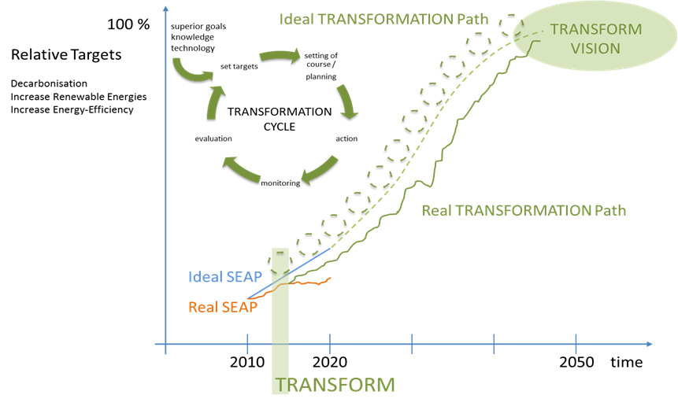
Figure 1 (b): Basic components of Transformation Management and Transformation Path towards long-term goals and vision.

For the progress of the Transformation Path as depicted in this figure it is essential to focus on those crucial challenges which enable significant advancements towards the city’s targets. These focus points can be identified and defined by setting criteria for prioritization.
The amount of advancements towards the targets of a city depends on the impact of a certain measure and on the ability of the city to implement it, as illustrated in Figure 6. Figure 6 divides a set of measures towards the city’s targets into four different sectors. The fastest visibility of results and progress can be achieved by measures which can be implemented with relatively low effort. The ability to implement these measures is high. Some of these measures have a high positive impact on the energy targets of a city, they are situated in the sector of so called “No Brainers”, others have low impact, so called “Low hanging fruits”. “No Brainers” are a good starting point for Smart City Activities. Nevertheless, the other sectors may not be neglected to reap the full potential of transformation for a city. Especially demanding are measures with a high impact, but the ability to implement is low. To address these measures it usually requires a significant effort in building ability and transformation of the city. These measures drive a Transformation Agenda. They have been the focus of the TRANSFORM cities.
To define the framework of themes, measures, impact and ability to implement and to be able to press ahead with processes for improvement through commitments, strategies and synergy effects, it is useful for cities to tap into the expert knowledge and experience of relevant stakeholders and the civil society. The involvement of relevant stakeholders and the analysis of their potential influence and interests are of particular importance. They enhance the validity and robustness of the chosen focus points in Step 3. Intake Workshops, as they were organized in the cities during the TRANSFORM project, can be recommended as a means to start. These Intake Workshops have an important function in the Transformation Process as an input tool for ideas, proposals, targets and involvement. Experts who have already been identified as decisive players via the Stakeholder Mapping procedure (see Step 2) are invited to engage in the Transformation Process. The Intake Workshop follows a certain methodology and employs several analysis tools such as the PESTLEGS Scheme and the SWOT Analysis. The methodology of the Intake Workshop is described more in detail in Annex 7: Intake Workshop.
With the help of the work from Steps 2 and Step 3 strategic alternatives can be formulated. The SWOT Analysis, the PESTLEGS Analysis and a set of Guiding Questions, to allow the calibration of the concept, support the development of sensible strategic alternatives.
Figure 6: Focus points to improve the development path towards the city’s Transformation Strategy.

SWOT ANALYSIS AND PESTLEGS ANALYSIS
The SWOT Analysis can be applied to identify the internal (strengths and weaknesses) and external (opportunities and threats) influences of the cities in order to find strategic alternatives, which can be balanced and selected for the cities’ strategic concepts. By developing the SWOT, awareness of all possible positive and negative factors that might have an influence can be created.
The results of the SWOT Analysis serve as the basis for the PESTLEGS Analysis. This analytical instrument allows to filter the SWOT results through the Political, Economic, Social, Technical, Legal, Environmental, Governance, and Spatial dimensions (refer to Annex 1: SWOT and PESTLEGS Framework for detailed information).

CALIBRATION OF CONCEPT ALONG GUIDING QUESTIONS
The strategic threads generated by the process as described above need to be combined and balanced in order to compose a raw strategic concept that provides the cornerstones and main statements of the Transformation Agenda. A tuning of the concept can be performed with the help of a Guiding Questions Assessment (see Step 2). As a result a prioritization shall evolve from the work in this step.

ADJUSTMENT OF STRATEGIC CONCEPT TO THE CITY SYSTEM AND INCREASE OF IMPACT

Step 4 comes back to the idea that this GTA functions as a guide for a regime shift as a long-term non-linear process of change: it shows a further improvement of the Transformation Model as a 4th Approach. In general Transformation Management has to be aware that urban system dynamics do not run smoothly towards strategic aims and visions without contradictions. Cities are complex and difficult to manage due to the different interest groups within the city.
- Decision-making processes are multi-layered and often not integrated. Inefficiencies may arise when different parts of the city are not working in unison.
- Changing the energy system also means changing consumer behaviors which is difficult to achieve from top-down.
- Citizen engagement is a crucial success factor in implementing ecological, economical and social change.
- In order to adjust the strategic concept and to increase its impact this GTA recommends a systems-perspective which takes different domains of urban dynamics and different actors on different scales into account.

Source: Transformation Agenda: Intake Workshop & SWOT Methodology. Manual for facilitators of the
workshop. October 17th 2013, Amsterdam by Accenture & ARUP.
In order to optimize the Transformation Process deeper insights into the ways this system works are an essential precondition for effective management (see also Annex 8: City as Complex Adaptive System and Smart Governance). Based on the PESTLEGS scheme those urban domains are identified which form the relevant TRANSFORM arenas to change the energy system (Figure 5). TRANSFORM arenas are dynamic socio-technical systems, constituted by actors as stakeholders, institutions and technical infrastructure. Their dynamic depends on various factors like information flows, innovation, power relations or organizational competencies. In general, rising efficiency might be expected by stimulating synergies and positive feedbacks or by avoiding isolated solutions and negative feedbacks. This 4th Step or Approach shows finally the deeper meaning of the “Transformation Cycle”, which was developed from the “Adaptive Management Cycle”. The focus is now not an abstract ‘Adaptive Cycle’, but rather the entire City as a Complex Adaptive System.
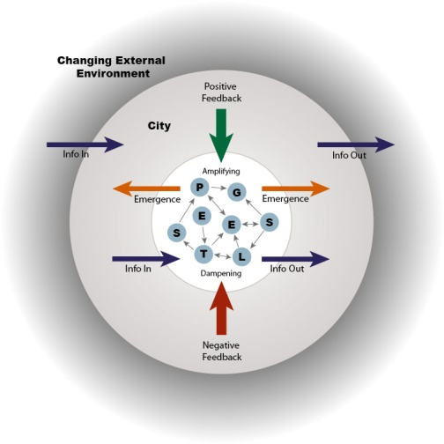
Figure 7: City as Complex Adaptive System based on PESTLEGS arenas
The GTA includes a governance mode leading to radical change by incremental steps in a participatory process. Within the context of the city transformation management (Figure 1, 8) targets, possible impacts and readjustments should be open to public discussion. In this way radical change towards the vision of the Transformation Agenda can be enabled by incremental steps in a participatory process. Basic characteristics of the GTA are flexibility (to changing system dynamics), a preference for diversity against rigidity and mono functional processes, ability to learn and refrain its coping capacities, anticipation of future trends and increasing adaptive capacities in order to increase resilience against external challenges and shocks.
The combination of the city model as adaptive system and the recursive management cycle including vision and aims of the Smart Energy City for 2050 allows to model a complex city transformation as “City Transformation Cycle” – as illustrated in Figure 8. Transformation governance enables an ongoing readjustment of the multiplicity of urban changes leading to growing decarbonisation, increase of renewable energies and of rising energy efficiency. It presupposes the ability of cities to follow certain principles of adjustment and an awareness of some factors conditioning modes of change.
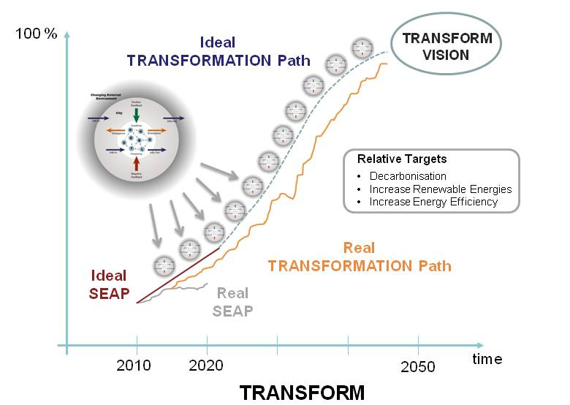
Figure 8: City Transformation Cycle
Starting point for the adjustment process of the strategic concepts are those results of the Intake Workshops which define the relevant 3-5 energy themes and proposed measures, the city is willing to push forward. Basically following principles should be taken into account:
- Integrated themes: Connect measures that integrate energy with urban planning, mobility including cross-cutting themes such as ICT and Finance.
- Integrated process: Involve internal stakeholders (departments + politicians) and external stakeholders such as civil society, industry, building cooperations, utilities, financial institutions to maximize shared values.
- Integrated action: Ensure that the planning of the energy initiatives and actions are coordinated in time and take into account spatial (i.e. plans per district).
Source: Transformation Agenda: Intake Workshop & SWOT Methodology. Manual for facilitators of the
workshop. October 17th 2013, Amsterdam by Accenture & ARUP.

Moreover, a successful change management has to be aware of temporalities, motivation and participation as well as multilayered decision-making:
- Temporalities: Because the GTA includes a time frame of decades links between long and short term have to be set up (Annex 8, Figure 3). This includes an understanding of long term system dynamics and a harmonization between strategies and aims along the time axis. It implies processes of for- and back-casting.
- Motivation and participation: The GTA relies on multiple actors which should be encouraged to contribute continuously to the transformation process in their domains beyond election time frames. Goals and visions are best achievable as emergent effects of bottom up activities which gives support for self-confidence and empowers capacities to act. This includes the creation of niches within the transformation processes as laboratories for desired urban futures and support for frontrunners.
- Multilayered decision making: The GTA presupposes different and connected modes of governance to coordinate and reinforce transformation processes. This includes the provision of existing rules and regulations, acknowledgement of cultural shifts, the encouragement of actors to go beyond what is legally required and shifts in practices, improvement levels of information, know-how transfer and education and the acceptance of being a role model leading to best practice operations.

TRANSFORMATION AGENDA AND DECISION SUPPORT ENVIRONMENT

The Generic Transformation Agenda outlined here describes the general structure of a City Transformation Management. Cities can use this GTA to develop their specific City Concept, i.e. a City Transformation Agenda including Action Plans and Financing Models. In the TRANSFORM project, each of the six cities have developed such a City Transformation Agenda. These serve as examples how this GTA can be applied in a specific city context. Furthermore, the GTA is strongly linked to two other products of the TRANSFORM project which can be used beyond the project partners:

- an area-based strategy in a selected district of each city, called Implementation Plan;
- a Quantitative Decision Support Tool helping to develop Action Plans and Implementation Plans.

The Generic Transformation Agenda supports cities and decision makers striving towards integrated energy planning: it delivers a Qualitative Decision Support Model. A Quantitative Decision Support Tool, developed within the TRANSFORM project, adds further knowledge and will assist and improve the transformation of cities towards Smart Energy Cities. City Transformation Agenda, Implementation Plan and the Quantitative Decision Support Tool are briefly described below.

CITY TRANSFORMATION AGENDA
A City Transformation Agenda is a concept that is based on the existing strategy of the city. It addresses the city as a whole and analyses the main factors of influence and impact. Factors to be analyzed are for example “main infrastructure and sources of energy (thermal energy, electricity, gas) and efficiency potentials. It also addresses the possible energy efficiency in flows of water, waste, IT and mobility. It includes urban planning procedures & regulation and the participation of end users. It is based on qualitative and quantitative insights and contains a strategic financial strategy“ (TRANSFORM Description of Work, Page 28). Each City Transformation Agenda has to contain a concrete Action Plan.

An Action Plan needs to be tangible and measurable. It is a citywide concept deduced from the developed strategy and approaches short- and medium-term targets. The Action Plan evolves from the work in Steps 1, 2, and 3. While the Action Plan addresses the city as a whole, Implementation Plans present solutions for specific city districts or other types of bounded city area.
Each Action Plan needs financing. Financing can be achieved by public funding, private investments or new business models. Cities’ approaches to intervene in the city to stimulate a transformation can be formulated as instruments like Financing Models, investment agendas or new business models. In Figure 9 some examples from TRANSFORM Cities and their partners can be found, which might be interesting for replication in other cities. A brief description of each example can be found in Annex 9: Examples of Business Models.

City | Example of Financing Model / Investment Agenda / Business Model
Amsterdam | Amsterdam energy and climate fund
Amsterdam | Amsterdam energy loan
Amsterdam | Amsterdam energy label cofinancing
Hamburg | Control Reserve
Hamburg | Solar Energy – 10 Megawatt Project
Hamburg | Solaratlas
Hamburg | Heat Supply Contracting
Vienna | Vienna Citizens’ Solar Power Station - BürgerInnen Solarkraftwerk Wien
Vienna | Developer Competitions by wohnfonds_wien

Figure 9: Examples of business models stimulating TRANSFORMATION

IMPLEMENTATION PLAN
In the TRANSFORM project six Smart Urban Labs (SULs) served as case studies for integrated energy planning. The Smart Urban Labs in Copenhagen, Genoa and Vienna (aspern Seestadt) represent urban development districts which attempt to create a major innovative breakthrough in the integration of building technologies, smart infrastructure and sustainable mobility concepts in greenfield or brownfield areas. The Smart Urban Labs in Amsterdam, Grand Lyon, Hamburg and Vienna (Liesing) deal with the transformation of fully or partly built-up urban quarters, taking up the challenge of technological and functional improvements of existing buildings and technical infrastructure to be combined with changes in the functional mix in the urban quarters.
For each Smart Urban Lab in TRANSFORM, an Implementation Plan was being drafted by the city and the stakeholders involved or by a development organization in charge. This making of Implementation Plans involved the use and synthesis of existing plans and ongoing planning processes and brought them to a comprehensive format. The Smart Urban Lab processes and the focus of their Implementation Plans in the 6 cities are individual in character and in scope of participation, but cover comparable main issues relating to the objectives of improving energy efficiency and increasing renewable energy components in their resource consumption.
Within the TRANSFORM project, the idea of Smart Urban Labs was created from several observations:
- New technologies are being applied first in individual projects, where testing can take place and learning for future improvements is being sought
- Smart urban technologies, however, need to be bundled and rolled out in a minimum of scale and applications, in order to provide a realistic test for further spreading out: Buildings, grids, energy production and storage facilities energy need to be developed and linked in coherent way
- Local networks and exchange of energy, renewable energy produced locally, the use of waste heat –all these relevant types of projects in a ‘smart neighbourhood’ related to energy and CO2reduction –need to be integrated in real urban uses, be they residential, services, offices or manufacturing
- This kind of ‘real life’ implementation in selected target areas (SULs) is needed in order to develop realistic strategies for the city wide development overall; this is particularly relevant in terms of the impact legal and economic framework conditions form for local implementation, but also with respect to technological innovations, which may be of quite different relevance in various parts of a city.
The vision of creating a smart future neighbourhood is the background of the SUL approach. It can be seen as working both ways, top down as an element in a city-wide transformation strategy or bottom-up, as an experimental way of learning and testing in order to develop the city-wide transformation strategy. In reality, both streams, up and down, will flow and work continuously: A city needs a general transformation strategy with binding targets, the implementation is being rolled out in the city’s neighbourhoods and from that experience the city-wide strategy will be adapted repeatedly, changing local implementation subsequently.
It seems essential that databases used, performance targets, urban development targets and the expected impacts of the measures taken in the IPs form a coherent system at the city-wide level (Transformation Agenda) and at the district or urban quarter levels (Implementation Plan). Ideally, the aggregate contributions of the numerous urban districts should form the basis for the achievement of the goals set at city-level. Since urban areas are most differentiated in terms of uses, densities, building types, etc., the general, city-wide transformation strategy needs quite substantial adaptations at the sub-city level. Therefore, performance targets will also have to be different between e.g. old urban quarters and newly built areas, where the latest technologies and know-how can be applied.
Main expected impacts of the Implementation Plan are carbon emission and energy consumption reduction, production of renewable energy and increased energy efficiency, but major impacts are also to be expected –but more difficult to be evaluated –in terms of jobs created, investments induced, energy imports saved, etc.). Highly relevant are also realistic data on the cost-effectiveness of measures, e.g. investment needed in relation to energy costs saved. Measures in the Implementation Plan are scalable.
More information about Implementation Plans in TRANSFORM can be found in Annex 10: Roadmap to make an Implementation Plan.

DECISION SUPPORT ENVIRONMENT
Decision support environment consisting of tools and best practices are assumed to support cities in developing a Transformation Agenda and subsequent Implementation Plans for specific districts per city. Both the Transformation Agenda and the Implementation Plan are supported by data analysis and Qualitative Decision Support Models and will prove that better economies are founded through integration of measures, sectoral views and through the cooperation of stakeholders.
The decision support environment consists of qualitative and quantitative decision support.

QUALITATIVE DECISION SUPPORT MODELS:
The Qualitative Decision Support Models are concrete solutions and process interventions, including innovative business models, financial strategy, participation and governance models and adapting planning processes. These models support cities in their strive towards integrated energy planning. The synthesis brings together the state of the art of transition thinking, derived from existing scientific knowledge and from the practical experience. The Qualitative Decision Support Model describes the substance of the Generic Transformation Agenda as well as City Transformation Agendas.

QUANTITATIVE DECISION SUPPORT MODELS:
TRANSFORM has developed a Quantitative Decision Support Model to complement the Qualitative Decision Support Model. The purpose of the quantitative decision support model is to make use of available data sets to produce quantifiable information stakeholders can use for energy planning and the production of low carbon scenarios. The tool shall assess the quantitative impact (quantified through key performance indicators) and costs of implementing hypothetical measures (at that city level or the local level) This information will support stakeholders in deciding which measures need to be part of the city’s transformation agenda. The quantitative Decision Support Tool can support the setting of themes and priorities as set out in Step 3 of this GTA. Figure 10 shows how the DSE and particularly the quantitative DS tool are embedded within the entire project.

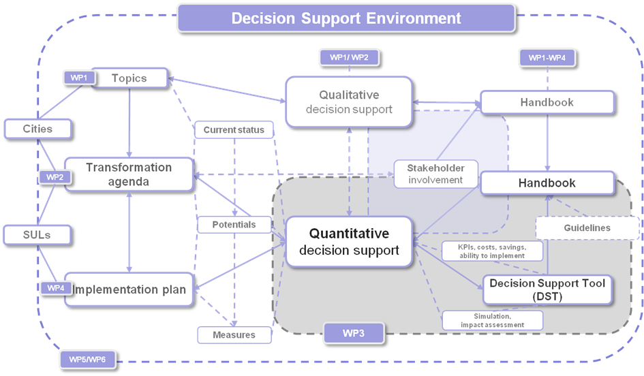
Figure 10: Embedding of the Decision Support Environment in TRANSFORM

Source: Concept AIT-Accenture (2013)

Further information on the DSE is presented in Annex 11: Quantitative Decision Support Environment.
Figure 11: The Quantitative Decision Support Tool helps to develop Action Plans and Implementation Plans.

PROCEDURES AND CITY DYNAMICS OF MONITORING, EVALUATION AND ADAPTATION

A continuous Transformation Process to turn the vision into reality needs an entire design of the City Transformation Management. Procedures have to be established which clearly describe serious and objective methods for monitoring of progress, evaluation of progress and adaptation within the city including responsibilities. That means an ongoing feedback process (“City Transformation Cycle”) with continuous loops of adaptation (as shown in Figure 6). Hence, finally we reach thelevel of the entire City Management: Figure 8 illustrates the complex adaptive City Transformation Management (see Figure 12).
Figure 12: City Transformation Management
TRANSFORM has defined a vision of a Smart Energy City (see Introduction). This vision goes beyond the targets of many current city concepts in terms of time horizon and absolute figures. A long planning interval in the ballpark of several decades is the basis to fulfill profound transitions towards goals and the vision of a Smart Energy City. With regard to profound long term transitions a single decade scope of e.g. SEAP obviously is a limiting factor.
A Transformation Agenda has to overcome the possible obstacle of uncertainty about the development in the city with regard to targets. The long planning horizon must be kept in mind in order to tackle far-reaching shifts towards the vision of a Smart Energy City. A city compatible approach designed by cities is needed to fit a substantial Transformation Agenda.
To overcome the obstacles described above a serious monitoring in the cities is needed to determine clearly the deviation from defined targets and to evaluate the development path. The monitoring should map the deviation of the results from targets in PESTLEGS categories to avoid sectoral limitation. A strategy which reacts on the deviations closes the loop to the city. This control and feedback structure as depicted in Figure 13 represents the basis to analyse and react on dynamic developments of the city due to internal or external effects. The figure shows one feedback loop: in fact it is a recursive formula which iterates an operation using the result of the previous operation as the starting point for the subsequent one. The result is a chain of feedback loops (see Figure 10). The strategy and the monitoring structures can be introduced by the Transformation Agenda and enhance the Transformation Process. They do not need to be static but are also subject to continuous modification.
Figure 13: Control and feedback structure to feed continuous dynamic loop city development as a basis for dynamic Transformation.

COMPOSITION OF THE TRANSFORMATION AGENDA

The assembly of the results originating from the previous 6 steps leads to the Transformation Agenda which holds targets for all time horizons. Its strategy focuses on the long-term perspective while its measures direct to the short- and mid-term development of the city. In order to reconcile all temporal different blocks of the Transformation Agenda, methods of anticipation, back- and forecasting should be applied. Furthermore the integration of accompanying research, experts and consultants can enhance the agenda’s level of quality. With respect to innovation and creative change management space for niches and experiments should be considered in the strategy. Frontrunners and change agents should be encouraged. Diversity is to be preferred over “one best way”.
A template to prepare a Transformation Agenda is provided separately by the TRANSFORM project [LINK]. The following table shows the steps of the GTA that can help to create content for each part of the template.
Contents of the Template | Steps to provide content
A - The Story: Status Quo, Story, Vision, Quantitative goals | Steps 1 & 2
B - Evaluation of the City Energy Strategy SEAP & Transformation Process | Step 3
C - Imroving abilities to implement: selected themes and strategic city WG | Steps 4 & 5
D – What has been achieved so far and impact on the city existing strategy | Steps 6 & 7

Figure 14: Interrelations between the “7 Steps” and the Transformation Agenda template

The illustration in Figure 15 summarises the most important elements – targets, strategy and measures – including the definition of a Transformation Cycle and puts special emphasis on a serious monitoring procedure. Responsibilities should be clearly allocated to each element within the City Transformation Team and partners. A continuous Transformation Management with repeating Transformation Cycle (“City Transformation Management”) then drives the development of the complex city system towards the TRANSFORM Vision as depicted in Figure 12 above.
Figure 15: Elements of a Transformation Agenda, including City Transformation Management and emphasis on monitoring procedure.

Overall and continuous Balancing of the Transformation Agenda to diminish obstacles and strengthen favourable factors:

Figure 16: Topography of the Balancing: turning the city society‘s status quo into low-carbon is the overcoming of obstacles and barriers (shown here as an increasing of social costs) as well as to support and strengthen favorable factors of Transformation towards a low carbon city (Source: WBGU).

ANNEX

ANNEX 1: SWOT AND PESTLEGS FRAMEWORK

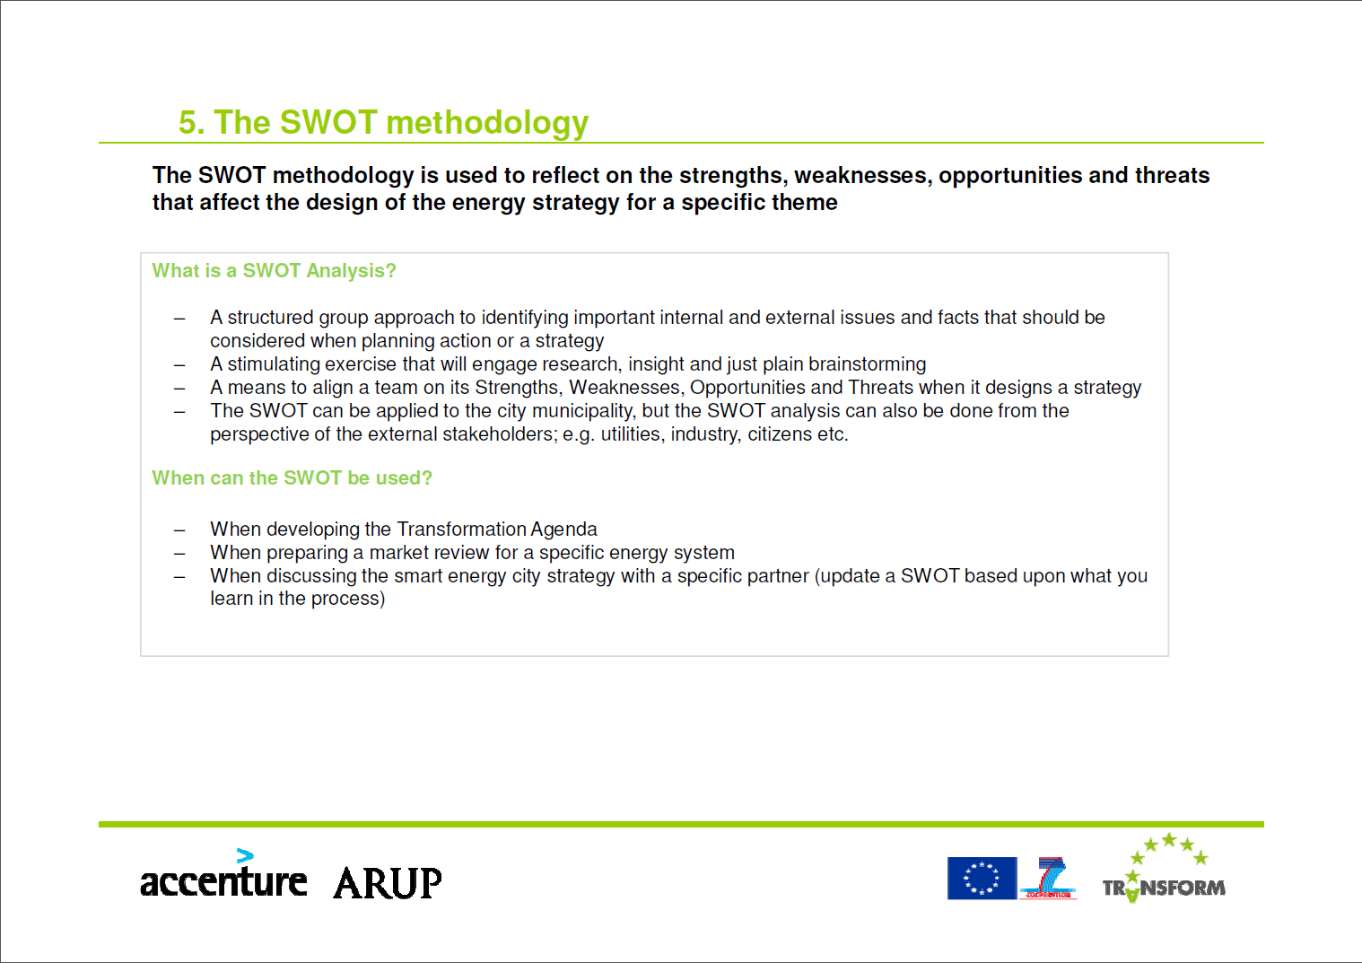
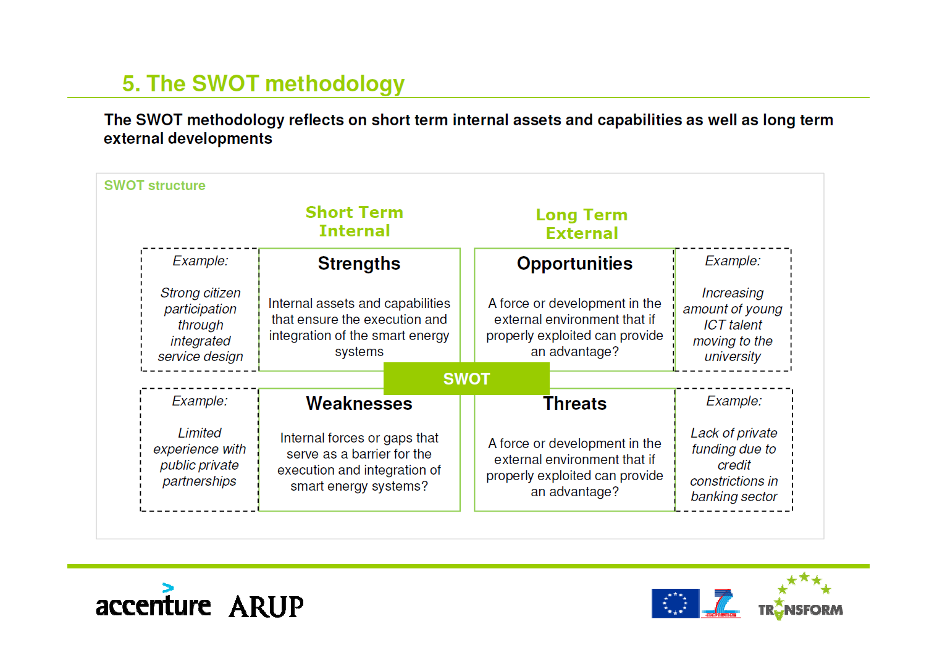
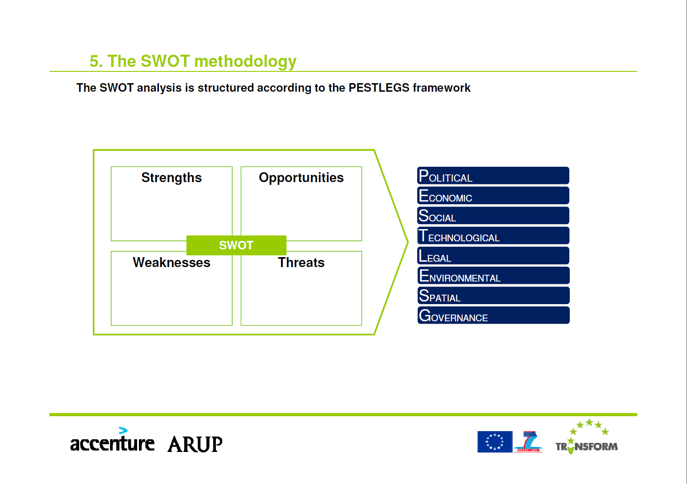
Source: Transformation Agenda: Intake workshop & SWOT methodology
Manual for facilitators of the workshop (Chart 22, 23 & 25)
October 17th 2013, Amsterdam, by Accenture & ARUP

TOPIC
PESTLEGS | Question | Strengths | Weaknesses | Opportunities | Threats
Politics | Do the topic points receive political support?
Economy | From an economic point of view, do the topics make sense? Can they be implemented?
Social | Are the topics socially accepted (public)?
Technology | From a technical point of view, can the topics be implemented?
Legislation | Are the topics in keeping with current legislation? Are there any legal obstacles?
Ecology | Do the topics affect  - Reduction in demand  - Energy efficiency  - Renewable energies  - CO2 reduction
Governance | Are all relevant stakeholders involved in planning processes?
Space | Are spatial aspects also considered within the topics?

ANNEX 2: BASELINE ANALYSIS

Document: WP1-Baseline-Context-for-Smart-Energy-Cities-NEW-May-2014.pdf

ANNEX 3: SMART ENERGY CITIES QUESTIONNAIRE

Document: 2013-Blank-Context-for-Smart-Energy-Cities-Questionnaire.xlsm

ANNEX 4: GUIDING QUESTIONS

- Definition of objective(s): How is the (main) objective/aim of the city plan defined?
- Well defined components of the city plan (e.g. CO₂ reduction, energy demand reduction, increase of renewable energy production or energy efficiency), using a clear quantitative and qualitative set of categories?
- Qualitative objectives only, which allow for different interpretations of how they can be reached best; or rather no explicit objectives – i.e. “the path is the way”.

- What is the underlying “philosophy” of the plan?
- Holistic and integrative approach, considering the interrelations between different components of the transformation agenda (e.g. the energy chain with respect to production, distribution and consumption).
- Segregated, additive approach. (Accentuation of individual sectors without consideration for interdependencies).

- Does the plan provide a specific timeline?
- Cleary defined milestones for short-term, mid-term and long-term targets as well as for the implementation of measures.
- Flexible and open timeline.

- Is the achievement of objectives monitored?
- A system of monitoring is in place which observes the transformation process and provides regular progress reports – with possible adjustments
- The process is designed to an open and flexible program. Specific objectives are negotiated on an ongoing basis.

- Is technical and social innovation (e.g. new energy producing technologies, changing consumer behavior) taken into consideration as an accelerator/catalyst for the city concept?
- The plan outlines the significance and possible directions of innovation as well as the ability to influence it.
- The plan does not reflect the potential impact of innovation. It does not attempt to stimulate and govern innovation.

- Does the plan reflect the spatial differentiation in terms of city scales (eg. building-, quarter-, district- or area-scale)?
- High level of differentiation with an integrative view on different city scales.
- City considered as homogeneous space.

- Does the city plan concern other themes of politics/governance?
- Integrated in other political concepts (multilevel governance)
- “Stand alone” plan

- What is the role of Stakeholders?
- Systematical, continuous participation in developing and implementation of the city concept (e.g. theme and agenda setting, part of governance)
- Selective, isolated participation, mainly priority for administrative acting

- Which other participative elements are included in the plan?
- A wide offer of options for participation, priority of action planning and experimental approaches;
- No explicit offer of options for participation

- Does the plan ensure a coordinated action within the administration?
- Comprehensive tasks are explicitly named and considered in the organizational processes;
- No coordinated action between different administrative areas.

- How well is the plan integrated in and secured by medium-term budget plans?
- The plan is secured, all measures are examined with regard to their financial dimensions and designed accordingly;
- Open financing depending on recurring negotiations

- Which energy themes are included in the city concept? Please, specify and list the energy themes.

ANNEX 5: LIST OF KEY PERFORMANCE INDICATORS

Document: WP1-revised-final-report-August_2014.pdf
A better document is needed. Somehow the list of KPIs is not included anymore.

ANNEX 6: STAKEHOLDER MAPPING

Summary - Stakeholder Mapping Task (WP2)

Context
Each city consists of multiple layers of living and technical systems, exposing great levels of complexity within them, but also interconnected with each other. The process of transformation towards sustainable cities should engage all of these layers in order to be effective. When considering urban transition towards Smart Energy City, vital roles are played by a great number of stakeholders, whether driving this process or involved in it to a variety of degrees and in different positions. Taking these dynamics into account, Stakeholder Mapping has been performed during Transform Project in five cities: Copenhagen, Genova, Hamburg, Lyon and Vienna. The city of Amsterdam attained the stakeholder related information in other local activities and therefore decided to skip this task.

Transform - Stakeholder Mapping
Stakeholder Mapping has formed a part of analysis of a city as a system, representing the actor/human side of a given urban setting. The aim of this task has been threefold: firstly, to portray the dominating categories of actors in the context of Smart Energy City development, secondly, to pinpoint their roles, making the local stakeholder configurations transparent and thirdly, to recognize the existing gaps in involvement and to potentially activate presently dormant potentials. The outcomes of Stakeholder Mapping are intended to be integrated in each city’s Transformation Agenda.

Stakeholder Mapping - Methodology
In three of the Transform cities the Stakeholder Mapping was undertaken in workshop settings, during which city representatives have provided inputs, listing currently active stakeholders and their roles. In the remaining two cities, the Stakeholder Mapping template, as designed and provided by AIT, was completed by the city representatives jointly with local project team, since workshops could not be arranged in all cities due to the organizational reasons and budgetary constraints. Going through a few rounds of review of the draft Stakeholder Mappings were necessary in order to compile the final version.
The task of Stakeholder Mapping was undertaken in the following four steps:
- General screening of actors, summed up in a broad overview of current stakeholders, pinpointing their roles and decision making/implementation capacities. This step included a simultaneous categorization of the actors by PESTLEGS categories, aligning stakeholders by their belonging to one of the following functionalities: Political, Economic, Social, Technological, Environmental, Governance and Spatial.
- Identification of present ‘driving stakeholders’, who have had the ‘driving role’ in the current development of a Smart Energy City in a given city context, predominantly concerning the local Climate Action Plans, SEAP, Framework Strategy and other local strategic documents carrying a variety of names.
- Identification of the gaps of involvement and definition of ‘required’ stakeholders in specific roles.
- Identification of the main stakeholders containing the strongest potential to set up, negotiate, modify and implement transformational measures, processes and actions as intended in each city’s Transformation Agenda.

The Stakeholder Mapping outcomes should be seen as ‘living’ documents. Available Stakeholder Maps can be continuously updated and used for tracking of the changes in stakeholder constellations and roles as well as for maintaining an overview on the engagement of the relevant actors in specific processes within city development. The Stakeholder Maps can also be used as reference documents and sources of information for the purpose of Stakeholder Management.

ANNEX 7: INTAKE WORKSHOP

Reference to Document: WP1-revised-final-report-August_2014.pdf
Part 3.2: Purpose & systematic of the Intake Workshops

ANNEX 8: CITY AS COMPLEX ADAPTIVE SYSTEM AND SMART GOVERNANCE

CITIES AS COMPLEX ADAPTIVE SYSTEMS – TOWARDS A PRAGMATIC DEFINITION
This comment builds upon concepts which outline research and action perspectives based on the idea of transformation and governance or transformation management on an urban scale (catchwords are urban sustainability, urban energy transition, resilient cities etc.). The theory behind follows arguments derives from new thinking about complex systems. Cities being conceptualized as complex systems consist of elements and interaction between social entities like citizens, stakeholders, parties, experts, NGOs, etc., institutional frameworks and arrangements, buildings and infrastructure. This perspectives derives from the field of science and technology studies and builts upon models of the dynamics and stability of large technical systems as it has been outlined by the influential work of Thomas Hughes who already emphasized different stages of system evolution where “physical artefacts, mines, manufacturing firms, utility companies, academic research and development laboratories, and investment banks” come together (Hughes 1983). Within theses socio-technical systems complexity is indicated by a process in which “an increasing number of independent variables begin interacting in interdependent and unpredictable ways” (Sanders 2008: 275). But that does not mean that conditions of stability and movements of change within socio-technical systems are an issue of ungovernability.
Elements of complexity concepts (see Box 1 and Figure 1) are used here in order to indicate both, the scope and interrelatedness of the energy system in our societies on one hand and the diversity, density and connectivity of cities on the other. The project TRANSFORM has to meet the combined challenge not only to outline a regime shift of an energy system on urban scale, which is able to meet the diverse needs of a city, but also to reconstruct urban complexities an energy efficient and saving way.
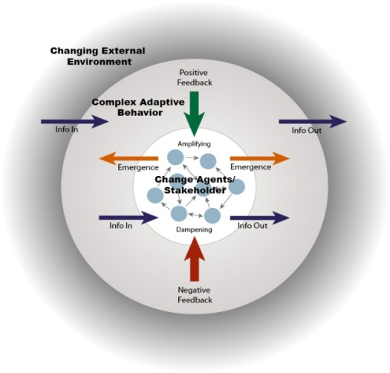

Figure 1: Characteristics of Complex Systems

Box 1: Complex Adaptive Systems Characteristics (Source: Sanders 2008: 276)
- Diversity (elements of a system are heterogeneous. They may vary in number and form during the system evolution);
- Predominance of nonlinear interaction (widespread flows of information, selection and feedbacks);
- Self-organization
- Limited information processing (agents “see” only their part of the system e.g. local interaction);
- Emergence (spontaneous order emerges from local interactions leading to unpredictable global behavior and patterns);
- Adaptive capacities (open and responsive to change to larger environment, continuously processing, learning, and incorporating new information, making boundaries hard to define);
- Multilevel organization (elements of the systems are organized on different nested or hierarchical scales, self-similarity of scales);
- Sensitivity to changes in initial conditions (small differences and changes can lead different pathways).
- Non-equilibrium (advantages for those systems operating between extremes of order and disorder including open space for niche development and frontrunners, making it easier to adapt to changing conditions.
- Best understood by observing activities, processes, adaptation of the whole system over time including qualitative description and understanding as well as quantitative modeling.
Systems are characterized by Self Organization, Emergence Relationships, Feedback, Adaptability Non-Linearity. Complex behaviors emerge as a result of often non-linear spatio-temporal interactions among a large number of components systems at different levels of organization.

SOCIAL COMPLEXITY AS OBJECT OF A GENERIC TRANSFORMATION AGENDA
The following argument emphasizes an actor-centred approach as it is outlined within the emergent transition school. “Our society is composed of complex adaptive systems in which individuals and organizations (may) self-organize within the limits set by physical, institutional and informal structures, and (can) experience the emergence of innovations of different types (e.g. technological innovations or social innovations in the form of new practices and/or routines)” (Loorbach et al. (2009) p 74). The multilevel perspective (MLP) on socio-technical transition is based on the interaction between three levels: Change derives from
- technological and social niches on a micro level where technological innovations co-evolve with novel forms of social organization (Note: there is a critique against the technological bias of MLP outlined by Geels and Schot 2007, see Bulkeley et al. 2014:1474);
- socio-technical regimes in various forms ranging from incremental reconfiguration to radical change in dependence of processes within niches or
- exogenous factors termed landscapes like resource shortages (peak oil), mitigation of climate change or hazards (Fukushima) leading to new strategies of energy provision.
Within TRANSFORM this MLP is adapted in the following way (Figure 2):
- The socio-technical regime is conceptualized as the urban energy system which is related to other urban systems (demography, land use, climate).
- The urban energy is not only embedded in other contexts of the city but in a broader system environment on different scale (Landscapes). Besides of those exogenous factors already mentioned, different political scales related to agenda setting and decision making are of mayor importance.
- Niches are conceptualized using the PESTLEGS scheme in order to address different transition arenas for complex co-evolution of new organizational forms, physical artefacts and practices.
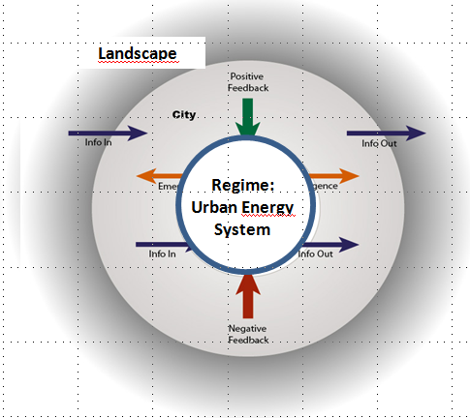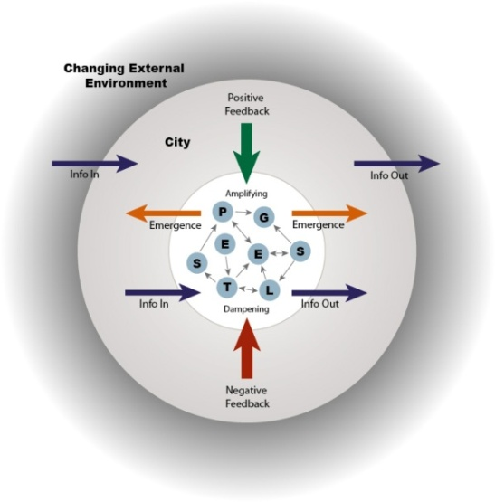
Figure 2: Complex Adaptive System applied to TRANSFORM (Multilevel Perspective)

DEFINITION OF TRANSITION GOVERNANCE
Though transition processes of complex adaptive systems are basically characterized by self-organizing principles contributing to development paths of ongoing change, the term transition governance is used here in order to delimitate a meta-level. Basically the term governance implies a descriptive and normative category. Concepts of transition governance are descriptive if a meta-level of societal interaction is addressed which may be defined as “the pattern that emerges from the governing activities of social, political and administrative actors” that “focuses on the interactions taking place between governing actors within social-political situations.” (Kooiman 2003, p. 7). When governing activities are related to collective beliefs, values, norms, indicators etc. governance is transformed to a normative concept which allows certain (political and administrative) actors to direct or orchestrate system change towards certain targets (Leitbilder, TRANSFORM = SEAP-targets).
The generic transformation agenda of TRANSFORM builts on insights of a body of work which uses the term “transition” to link science and technology studies to innovation research. The following chapter summarizes main ideas and empirical results of this literature which has already been introduced in applied urban research on EU-level (DRIFT xxxx, Nevens et al. 2013).
In general the term transitions describes 'societal processes of fundamental change in culture, structure and practices' (Frantzeskai and de Haan (2009). Though transition concepts usually address fields of the socio-technological systems like energy, water and mobility within the context of sustainable development, it must not be reduced to simple technological innovations but should be seen as systematic innovations accompanied by 'changes in markets, user practices, infrastructures, cultural discourses, policies and governing institutions' (Nevens, F. et al (2013), p.112).
In temporal perspective transitions are conceptualized as long-term processes that require time-sensitive thinking, where multiple domains and different actors are involved including constant learning processes, system innovation and reflexive critique. Simultaneously the aims and schemes need to remain flexible due to possible changing conditions and to uncertainties regarding future developments. Additionally concepts of transition are usually related to space and are often found in a city context, though they are not necessarily connected to an defined scale, particular place or defined sectors.

Figure 3: Correlation between „Impact“ (Energy Themes/Measures) and ability to implement (PESTLEGS)
The transition process asks for a holistic and fundamental change of the present situation. Based on an understanding, that every single person and organization have an influence on sustainability by everyday decisions and behavior "neither local government nor any other single actor can address sustainability challenges on its own" (Roorda, C. et al (2012), p.6). Thus, it is necessary to address all kinds of actors in the transition process to inform and get positive as well as negative feedbacks but also all kinds of help in terms of know-how, creative thinking and support (Nevens, F. et al (2013), p.115).

CHARACTERISTICS OF TRANSITION MANAGEMENT FROM AN ACTOR-CENTERED PERSPECTIVE
According to the concept provided by DRIFT we might distinguish different ranges of actors involved in the transition process depending on the stage of the process. First, the transition team is responsible for the initiating, organizing and structuring of the whole process as well as connecting the participants of the process with policy officers. Employees of the initiating organization, experts in the field under study, transition management experts and process facilitators are involved in this group (Nevens, F. et al (2013), p.116f.). Second, the so called change agents (arena group) are enabled to think beyond business as usual and create a long term vision of the transition (Roorda, C. et al (2012), p.16). The arena group include people from various backgrounds, domains and with various competencies in order to gain the highest possible know-how, diversity of interests and ways of novel thinking. The aim is to guarantee the creation of a vision that suits as many people involved as possible and is mostly independent from the current system. It is essential to address and chose individuals that do not represent the interests of one single actor like a company for instance, but are open minded and willing to appreciate other perspectives and get honestly connected to the issue (Roorda, C. et al (2012), p.16).
Because transition describes a fundamental change in culture, structure and practices within different domains and concerning all kinds of actors, the question arises how to initiate and governance such a process. A constellation should be set up in which an exchange between different actors concerning various topics is possible leading to new arrangements, programs, projects and an implementation of innovations (Nevens, F. et al (2013), p.114). These objectives of transition management include elements of 'learning-by-doing' and 'doing-by-learning' during the process (in Verbong, Loorbach, D. et al 2012, p.79).
Transition management may be subdivided into distinct phases and transition fields. An example has been provided by DRIFT based on experiences from the project called 'MUSIC' which included five North-Western European cities. The project should 'catalyze and mainstream carbon and energy reduction in urban policies, activities and the buildup environment' (c.f. Verbong, Loorbach (2012), p.5). The phases describe typical activities within a chain of activities and implementation efforts. Feedback loops and overlapping periods have to be recognized as normal features of process organization.

Sources:
Bulkeley et al. 2014: Low-carbon Transitions and the Reconfiguration of Urban Infrastructure. Urban Studies 51(7), 1471–1486
DRIFT (2011): Urban Transition Management – Manual: „Navigator‟ of the MUSIC project.
Geels, F. W., Schot, J. (2007): Typology of sociotechnical transition pathways. Research Policy 36, 319-327.
Kooiman, J. (2003): Governing as governance. London:Sage
Loorbach et al. (2009): Transition Management for Sustainable Development: A Prescriptive, Complexity-Based Governance Framework. Governance: An International Journal of Policy, Administration, and Institutions, Vol. 23, No. 1, 161–183).
Verbong,G., Loorbach, D. (2012): Governing the energy transition. Reality, illusion or necessity? New York:Routledge
Nevens, F., Frantzeskaki, N., Loorbach, D., Gorissen, L. (2013): Urban Transition Labs: co-creating transformative action for sustainable cities, Journal of Cleaner Production 50, 111-122.
Roorda, C. et al (2012): Fundamentals in Sustainable Development. London:Routledge.
Sanders, T.I. (2008): Complex Systems Thinking and new Urbanism. In: T. Haas (ed):New Urbanism and beyond : designing cities for the future. New York, NY : Rizzoli.

Box 2: Six Phases of Transition Management (Nevens, F. et al (2013), p.114f.)
Phase | Description | Involved actors | Methods | Outcomes
I  Analysing the system | In the first step, it is essential to get a holistic overview about the system with its relevant actors, institutions, their interrelations and the key system functions by using quantitative and qualitative research methods. This system analysis provides all transition actors with the same information; so that they can all start from one level and have a common understanding which facilitates the following phase of envisioning. | City administrators;  Specific content experts;  Transition management experts;  Process facilitators;  Experts, data-owners, stakeholder. | Consultation and communication, brainstorming, actor mapping tools, transition management framework, soft-system methodology, semi-structures interviewing, desk top data collection, sounding board sessions. | Zone for co-design;  Creation of a transition team,; fexible process design;  System analysis.
II  Envisioning | In this phase, the actors are in demand of creating an 'appealing and inspiring vision' in order to 'provide long-term orientation and guidance, mobilize support and enroll resources'. Furthermore, the visions' function is a connection of the actors to each other as well as to the transition approach. | Frontrunners (visioneers);  Creative individuals (artist, designers,…); | Arena meetings; brainstorming/scenario workshops; artistic conceptualization. | Creation of transition arenas; participatory problem structuring, definition of key priorities, definition of guiding principles.
III  Exploring pathways | The third phase serves to develop different strategies (pathways) to achieve the aims of the long-term vision, especially by using the 'back-casting method' to simplify the mid- and short-term perspective. After having developed a long-term vision and different pathways to reach it, it is time for the phase of experimenting. | Frontruners; action-orientated networks, pathway-specific actors (experts, industry, government, civil society, citizens, …); | Pariticipatory back-casting, model-based scenarios, facilitating of networking, creation of business models, cost-benefit analysis | Major systemic turns to be realized;
IV  Experimenting | The experiments take place in 'real-life' and are defined as having a high level of risk in order to satisfy the ambitious aims of the transition by enabling crucial results. The experiments are committed to address societal challenges with radical changes in culture, structures or practices (or altogether) and focus on a learning process | Managers, clients, citizens, financiers | Fund raising, project planning and management | Existing and new transition experiments; demonstrators for the transition process
V  Assessing | The next step addresses oneself to the task of triggering more action after the phase of experimenting. In doing so, instruments should be designed under the same terms as during the envisioning process (enabling a wide spread of interests and domains) to create follow-up actions. In order to achieve relevant changes, monitoring and assessment is important to verify the effectiveness of actions, but to make it clear at this point: 'monitoring instruments are not designed to 'measure' but to trigger action, to enhance system change in a desired direction'. Besides, the phase of assessing is equally supposed to monitor the transition management as to forward the social learning process. | Transition team; action researchers, various actors | Interviews, reflexive sessions, action research | Adaptation of strategic approach, adaptation of the generic transition framework, lessons learnt, knowledge sharing.
VI  Translating | The last phase of the transition management process describes the actual initiation of the transition as 'activities have to be incorporated and multiplied in actions of the relevant system stakeholders' which implies all actors that are in any way included in the system. This is the determining phase that sums all previous work up and shows its effectiveness towards real-life change.

ANNEX 9: EXAMPLES OF BUSINESS MODELS

Amsterdam
Amsterdam energy and climate fund
A revolving fund (app. 60 mil. euro) which lends out capital for market price interest rates (7-8%) but for cases with a high risk profile (where the traditional financial institutes would rise their interest rate). This way also risky business cases or not proven technologies/innovations can be financed. The loans will be returned after 5-10 years when risk has diminished and/or technology has been proven. For example traditional financial institutes could take over the loan.
Turn of: app 80.000 euro a day.
This instrument was recently awarded with first price on the C40/Siemens Climate leadership awards.
http://www.akef.nl/
http://www.amsterdam.nl/gemeente/organisatie-diensten/dienst-ruimtelijke/wij/klimaat-energie/fonds-klimaat/
http://cityclimateleadershipawards.com/wp-content/uploads/2014/09/CCLA-2014-Winners.jpg

Amsterdam energy loan
A low interest energy loan (2%) for private house owners. Private house owner can borrow money from the municipality for energy measures (efficiency and production). The fundable measures are listed.
http://www.amsterdam.nl/wonen-leefomgeving/energiebesparing/energielening/

Amsterdam energy label cofinancing
A cofinancing instrument for housing cooperations (social housing). Once a housing cooperation invests in energy measures (efficiency and production), the municipality pays for half the costs. The indicator is energy labels: per label step, half the costs is cofinanced. The number of label steps per 4 years is agreed on with the housing cooperations in the policy/contract ‘Bouwen aan de stad’. This policy will be examined in for the new City’s sustainability plan “Amsterdam sustainable’ (our TA).
Labels steps made in period 2010-2014: 16.000, cofinancing app. 32 mil. euro
First implemented in 2010.
http://www.amsterdam.nl/gemeente/organisatie-diensten/wzs/container/documentatie/onderzoek-woonbeleid/onderzoek-woonbeleid/overeenkomst-bouwen/

Hamburg
Control Reserve
The municipal energy provider HAMBURG ENERGIE develops innovative projects within the Information and Communication Technology (ICT) in order to find solutions for intelligent energy supply.
In so-called Virtual Power Plants (VPP) many decentralized renewable energy resources can be pooled, allowing an intelligent control for a tailored energy production. This also enables one regenerative energy generation plant to substitute for another, hence, guaranteeing a stable energy supply if necessary. In those intelligent interconnections renewable energies are able to provide control reserve – a system-level service used by Transmission System Operators (TSO) to maintain the nominal power frequency. Integrated as system-level service into a VPP control reserve can deliver a considerable yield. It is expected that due to the increased use of volatile (renewable) energy sources, the need for control reserve will increase.
The VPP implemented by HAMBURG ENERGIE is generally open for all energy generation plants free from coal and nuclear. HAMBURG ENERGIE trades with the bundled power. By inserting the surpluses into the grid, unnecessary losses can be avoided. Through decentralized renewable energies the end consumer is not dependent on one big power plant and the proximity to customers minimizes losses due to transportation. In the future, VPPs will combine storage and consumption units additionally to generation.
The current plants for control reserve exist in the suburbs of Hamburg, though it is planned to integrate more of them into the urban area in the near future.
With the development of such a model, HAMBURG ENERGIE proves that it is technically possible to combine renewable energy sources in a VPP in order to provide control reserve, and grid stability. In the long term, energy should originate 100 percent from renewable sources.
First implemented in 2012.

Solar Energy – 10 Megawatt Project
HAMBURG ENERGIE generates energy by using multiple kinds of renewable energies, such as solar energy generated through by photovoltaic plants.
In order to estimate the solar potential, the roofs in Hamburg were scanned, data collected and analyzed. The result was very positive. In corporation with its subsidiary HAMBURG ENERGIE SOLAR, HAMBURG ENERGIE has started and successfully finished the “10 Megawatt” Project in 2011. The installed PV units provide power for more then 3.000 households. Hamburg’s citizens were able to take part in this project and support its development by either renting their rooftop spaces (if bigger than 1.000 m2) or by assets. The installations can for instance be found on the roof of the well known soccer club “FC St. Pauli” or on historic buildings from the 1950s.
As of today, HAMBURG ENERGIE operates with 26 solar power plants with an overall production capacity of 12 MW, providing electricity for 4.000 households. This results in a CO2 mitigation of 6.200 t per year.
First implemented in 2011.

Solaratlas
The citizens in Hamburg can become part of the climate action ambitions and install a photovoltaic plant on their roof. HAMBURG ENERGIE and the Ministry of Urban Development and Environment have developed the “Solaratlas” which helps interested citizens to evaluate their roof’s potential for solar energy. Citizens can access the “Solaratlas” for free via the website of Hamburg Energie. The usability is high – only address and house number need to be inserted and the user immediately receives information about the potential of his/her rooftop.
First implemented in 2011.
http://hamburgenergie.de/privatkunden/energieerzeugung/solaratlas/

Heat Supply Contracting
The energetic standards for real estate such as energy efficiency and primary energy consumption are currently undergoing a great development in Germany and shall prepare a transition to a climate neutral building stock by 2050. Latest changes mainly concern new buildings and renovation projects.
Building owners need a competent partner to align their projects to the new requirements, especially with respect to the key component: heat supply. Since each real estate is different regarding number of dwelling units, size and location, customized solutions are key. The concept of heat supply contracting with long-term planning security facilitates the application of cutting-edge system technology. Energy/heat is generated directly where it is needed, which increases efficiency and minimizes losses. Additionally many more options to design a comprehensive, sustainable and economic concept for heat and electricity supply can be exploited with a contracting partner who masters the complexity of legislation, of technology and of project management.
As an example HAMBURG ENERGIE offers solutions, which comprise a high level of self-produced electricity from CHP plants, for large properties with a considerable number of dwelling units. Building these plants requires a high investment from the contracting partner who solely carries the investment risk. The energy efficiency orientated solutions also aspire the right balance between measures for thermal insulation and innovative system technology for the heat supply in order to minimize problems with massive thermal insulation for buildings.
This new concept with focus on self supply of heat and electricity represents a challenge in light of the liberalized energy market in Germany and is rarely to find yet.
First implemented in 2010.

Vienna
Vienna Citizens’ Solar Power Station - BürgerInnen Solarkraftwerk Wien
First project that allows citizens to actively participate in the foundation and construction of solar power plants in urban areas by becoming co-owners of solar plants. It is a great opportunity for citizens to partake in promoting and exploiting renewable energy, especially for people who live in rented accommodation (i.e. around 80% of the population in Vienna). Every citizen can buy solar panels at a price of € 950 per panel. Wien Energy builds the photovoltaic modular units for the solar plant. The buyers lease back their panels to Wien Energie with a predicted annual return of 3.1 %. Every single buyer can purchase between 0.5 and 10 panels. Meanwhile there are 16 power plants producing 5,000 MWh per year (500 – 2000 panels per plant). All of them were sold out very fast.
First implemented in 2012.
http://www.buergerkraftwerke.at

Developer Competitions by wohnfonds_wien
As a strategically placed non-profit organisation, wohnfonds_wien coordinates property developers, house owners, municipal departments and service centres of the municipality of Vienna. It is both an agency for urban renovation and the supply of new housing opportunities. With regards to the supply of new affordable housing, its main activities concern site acquisition, site planning and co-ordination with relevant authorities, land valuation and resale, subsidy allocation, organisation of development competitions, sale of sites to eligible and approved developers. Wohnfonds_wien influences market processes with different instruments. One of these is the developer competition. These competitions are conducted between applicants in order to promote development according to local planning and housing objectives, increase quality and cost effectiveness. Competitions for available sites and subsidies also promote transparency, innovation and efficiency in project proposals. Wohnfonds_wien transfers land to successful non-profit housing companies at a set maximum prices per square meter. There are two price levels: one applying to the city centre, the other to outer suburbs.
http://www.wohnfonds.wien.at

ANNEX 10: ROADMAP TO MAKE AN IMPLEMENTATION PLAN

Document: D41_Making_of_IPs_Draft_40.pdf
Needs to be replaced by the final version.

ANNEX 11: QUANTITATIVE DECISION SUPPORT ENVIRONMENT

Document needed.

TRANSFORM, Work Package 1: ‘Becoming a Smart Energy City, state of the art and ambition’, Definition of Smart Energy City
Smart Urban Labs … [short reference and explanation to the DoW and the concept of SULs]
www.eumayors.eu/IMG/pdf/seap_guidelines_en.pdf
http://ec.europa.eu/europe2020/europe-2020-in-a-nutshell/targets/index_en.htm, 12 November 2014
http://www.ipcc.ch

